**ACTIVITY DIAGRAMS FOR THE CAR-RENTAL WEBSITE:-**

1. **Placing The Order:-** 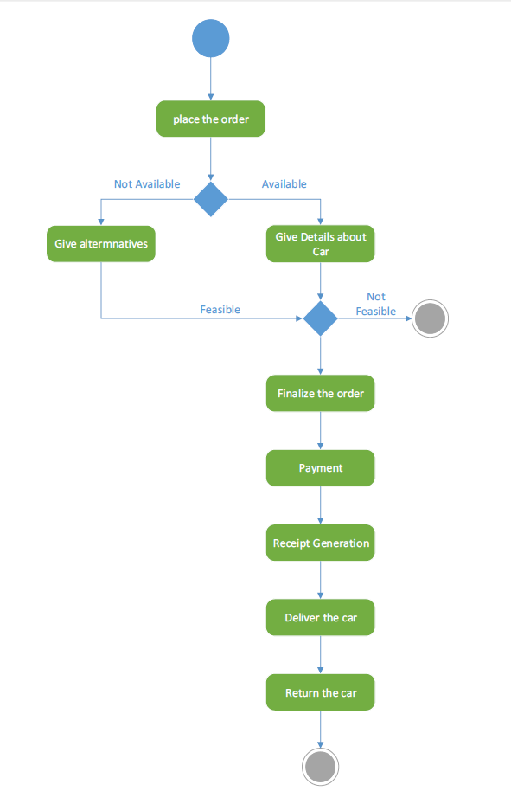
2. **MEMBER REGISTRATION:-**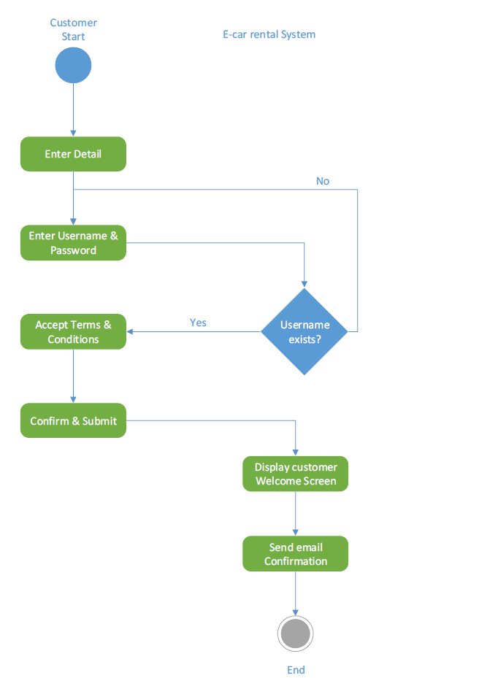
3. **PROFILE MODIFICATION:-**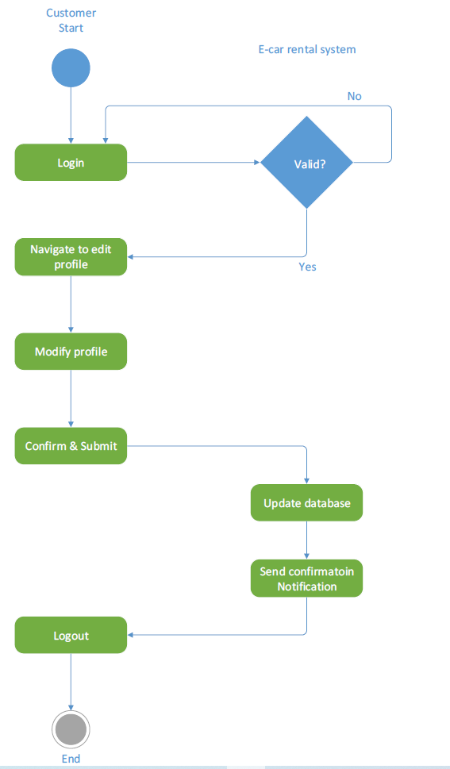
4. **RESERVATION OF A CAR:-**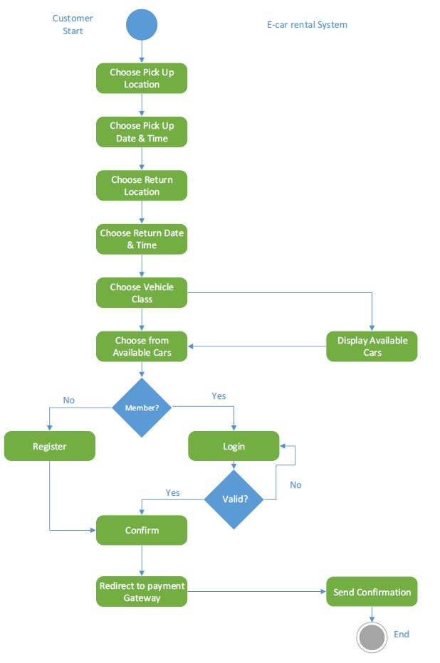
5. **PAYMENT OF CAR RENT:-**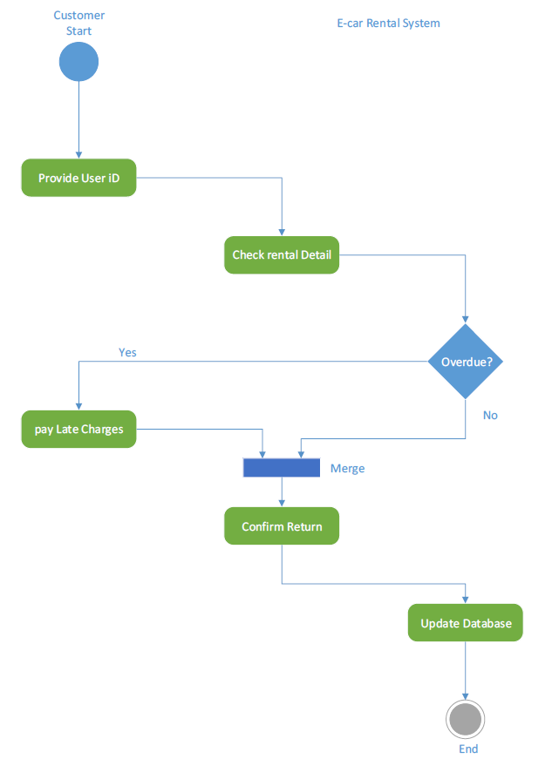
6. **ADDING A NEW CAR:-**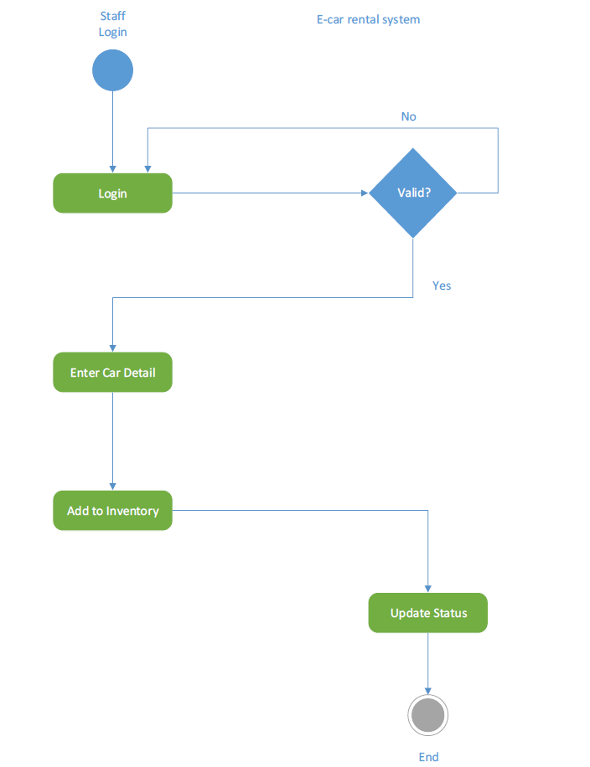
7. **VIEW REPORT**